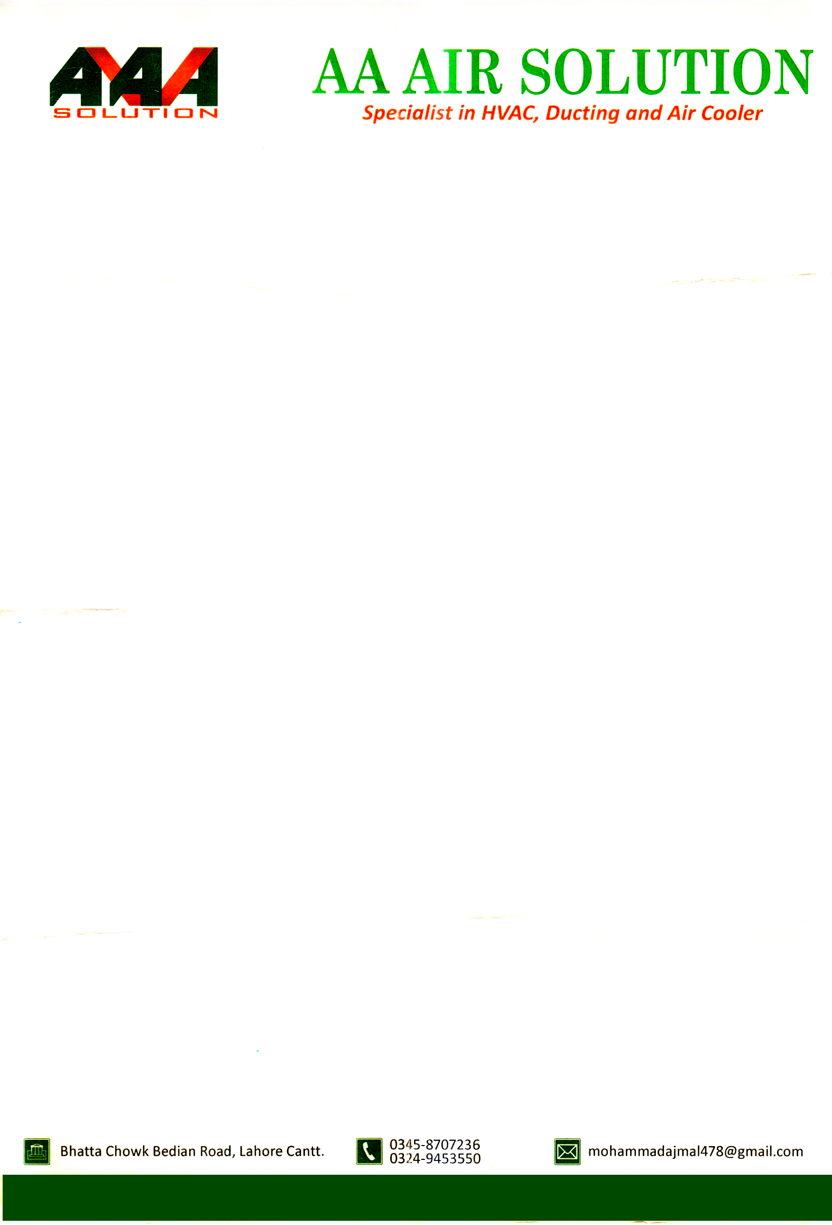

Date: <To>

**TO WHOM IT MAY CONCERN**

It is certified that Mr. <Name> S/O <fname> CNIC No. <CNIC> worked in our organization as <Designation> in Technical Department from <From> to <To>.

During Service we found him hard working and professionally sound.

We wish him great success in his future.



**MUHAMMAD AJMAL**

**Proprietor**